A Model Context Protocol (MCP) Server for Uniform Guidance
Sabrina Woo
May 8th, 2026

Background
Developed by Anthropic in late 2024, the Model Context Protocol (MCP) is an open, standardized interface that allows Large Language Models (LLMs) to interact with external tools. This pilot project creates a local MCP server designed to provide structured access to policies within Uniform Guidance (2 CFR 200) via the Electronic Code of Federal Regulations (eCFR) application programming interface (API). The eCFR API is maintained by the National Archives and the Office of the Federal Register and provides a data feed of tracked and updated federal regulations. The eCFR API can retrieve specific sections of regulatory text without manual searching or downloading static documents. When combined with MCP, the eCFR API becomes a source of up-to-date compliance information for AI-driven systems.

How MCP Works
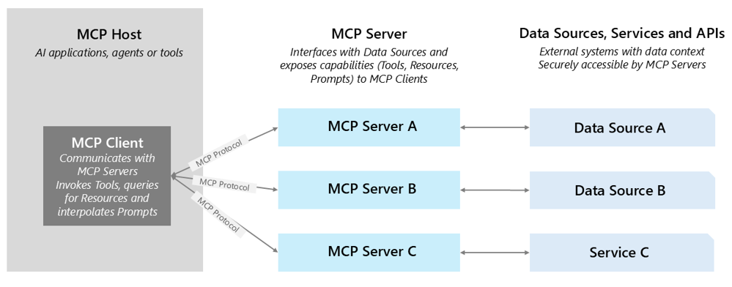
Model Context Protocol acts as a bridge that connects AI to external tools or data. The AI client issues structured requests to purpose-built MCP servers, which communicate with external services such as databases, APIs, or file systems. Results are returned to the model in a consistent format, allowing it to reason over live, external data without requiring direct integration logic. The design of this protocol allows it to be model agnostic, so any LLM agent can use it.

Why We Chose an MCP Framework
MCP servers extend AI capabilities by enabling more agentic, trustworthy workflows, including integrations with custom clients such as Vandalizer. In this pilot project, MCP grounds AI responses in traceable federal policy text, supports direct citations, and gives agents the context needed to identify relevant CFR sections more effectively than users who may not know where to search. It also reduces technical complexity by abstracting direct interaction with the eCFR API, which can return JSON or XML outputs that are difficult for non-technical users to work with. Additionally, MCP eliminates the need for separate database infrastructure and provides a scalable way to access continuously updated federal policy text from the authoritative source.

Current MCP Framework
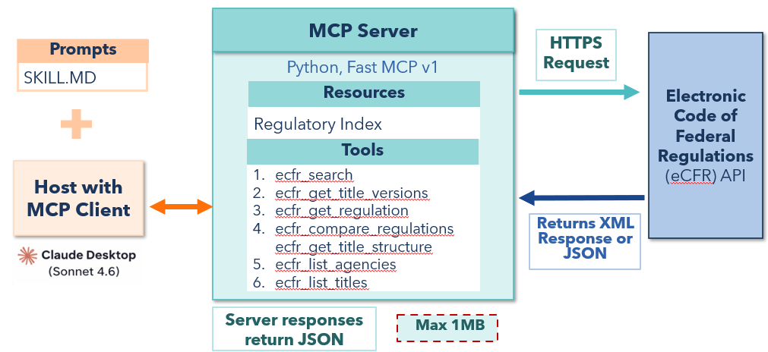
This framework uses a local MCP server as a controlled connection between Anthropic’s Claude Desktop (Sonnet 4.6) and the eCFR API. The MCP server exposes a focused set of tools for searching, retrieving, comparing, and navigating CFR content in compact responses. For open-ended questions, the AI agent should begin with ecfr_search to identify relevant sections. For specific regulatory lookups, the agent should first call ecfr_get_title_versions to obtain a valid amendment date, then pass that date into ecfr_get_regulation. This tool sequencing is essential because CFR part numbers are not globally unique across titles, and reliable lookups require valid version dates. The other tools are executed based on the question and the agent’s reasoning.

Pros and Cons of MCP
MCP offers several advantages for AI-enabled workflows. In this implementation, it supports exact citation text, stronger traceability, clearer provenance, and access to current federal policy language. It also helps produce more consistent responses, decreasing the uncertainty of AI outputs. MCP is relatively easy to set up and use, can be customized for different use cases, and can be extended with additional tools or scaled over time through enterprise cloud hosting.
However, there are limitations to consider. MCP-based responses may not always provide broader contextual information and may fail to incorporate external sponsor guidelines. Response times can be longer than standard model interactions which may lead to higher crash rates. In addition, smaller or older models (e.g. Haiku) may struggle to use MCP effectively. Context window limits and tool response maximums can constrain output quality, especially for complex requests.

Evaluation Insights
- AI responses without MCP performed worse in factuality and relevancy metrics.
- Both Human and AI Evaluation gave better accuracy scores to MCP generated responses.
- LLM-judged responses showed a positive correlation between comprehensiveness and accuracy, while human-judged responses gauged the two metrics independently.
- MCP tool efficiency varies by question type, with specific questions yielding better results and hypothetical "what-if" questions performing worse.

Resources
This project was funded by National Science Foundation grant 2427549 and presented at the 2026 Research Evaluation and Analytics Community Hub Summit.

eCFR API Documentation
AI4RA Github Repo
Anthropic Model Context Protocol

